SAMPLE DEPLOY REQUEST JSON FILE
{
"Deployment":"Undeploy",
"targetIP":"targetIP",
"targetPswd":"gtu2017A",
"destination":"3",
"source":"3"
}

SAMPLE UNDEPLOY REQUEST JSON FILE
{
"Deployment":"Undeploy",
"containerID":"5ad1c5f0b9e8",
"targetIP":"targetIP",
"targetPswd":"gtu2017A",
"destination":"3",
"source":"3"
}

SAMPLE DEPLOY SUCCESS RESPONSE JSON FILE

{"Deployment": [{
"State": "Success",
"Deployment": "Deploy",
"ContainerID": "8b254e53a2b8",
"destination": "3",
"source": "3"}]}

SAMPLE DEPLOY FAIL RESPONSE JSON FILE

{"Deployment":
[{"State": "Failed",
"Deployment": "Deploy",
"ContainerID": "8b254e53a2b8",
"destination": "3",
"source": "3"}]}

SAMPLE UNDEPLOY SUCCESS RESPONSE JSON FILE

{"Deployment": [{
"State": "Success",
"Deployment": "Undeploy",
"ContainerID": "8b254e53a2b8",
"destination": "3",
"source": "3"}]}

SAMPLE UNDEPLOY FAIL RESPONSE JSON FILE

{"Deployment":
[{"State": "Failed",
"Deployment": "Undeploy",
"ContainerID": "8b254e53a2b8",
"destination": "3",
"source": "3"}]}

SENDING JSON RESPONSE

First to test if we can send a response we need to make a listener.

API Client in flask :

https://github.com/PrettyPrinted/http_request_python_tutorial

download the restful.py file.

API is in flask so first download flask.

$ sudo apt install python3-flask

Listens the port. This is needed to test if we can send the response.

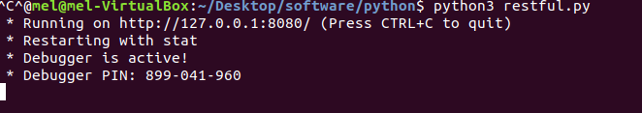

When we run our code, sends a response json file to the destination.

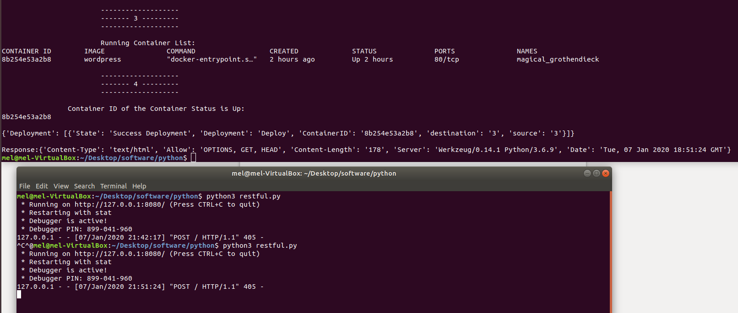

UNDEPLOY:

1- Gets request
2- Parses the json file
3- Deploys or Undeploys
4- Sends response

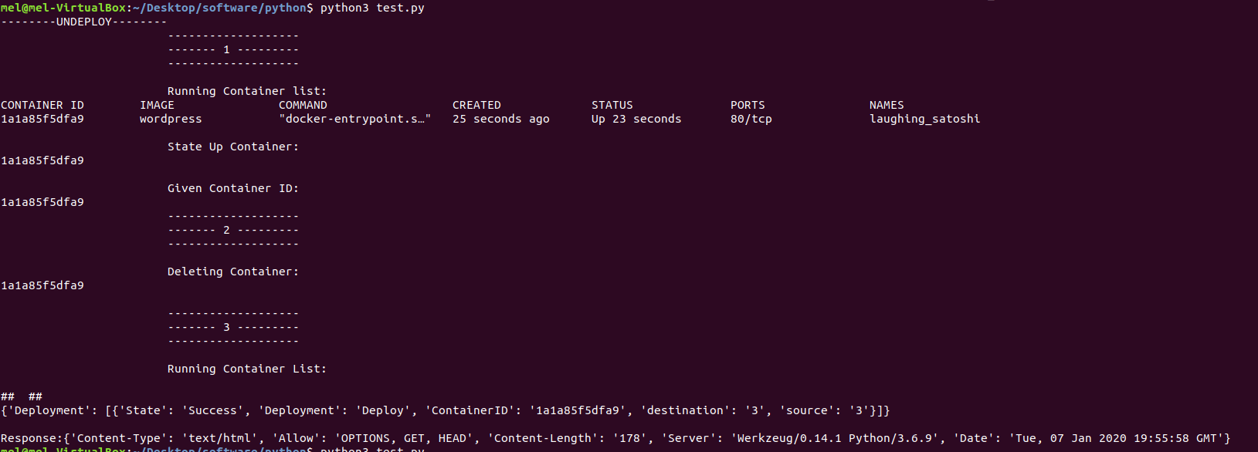

Anypoint

HTTP : Listens to port

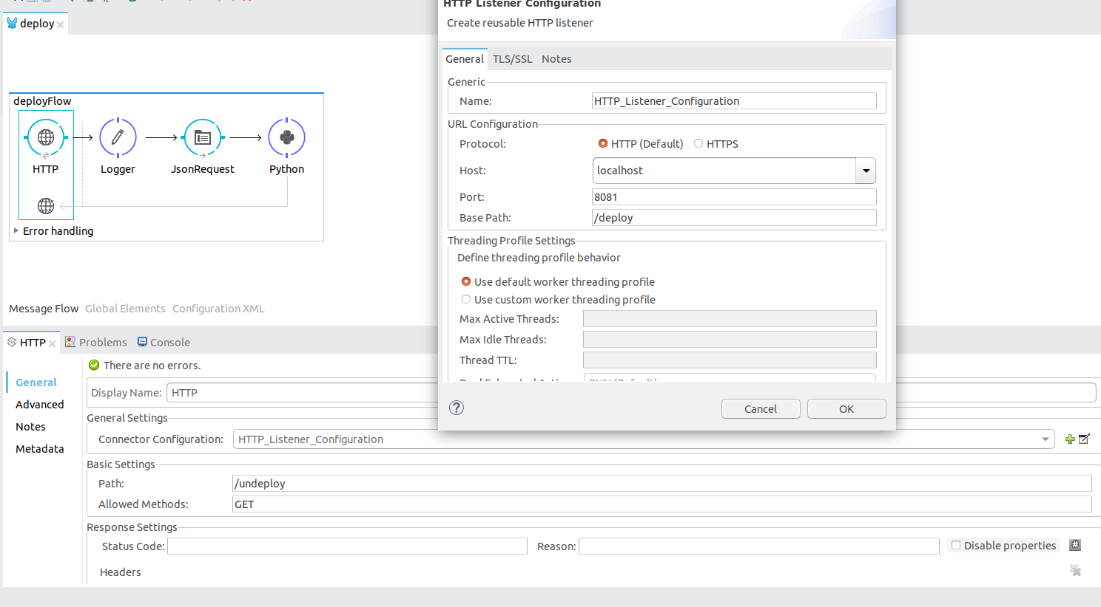

Logger :

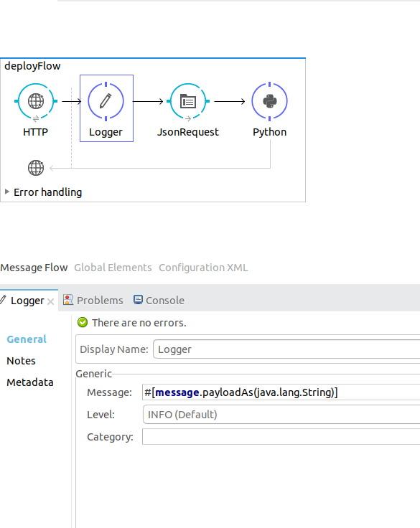

File:

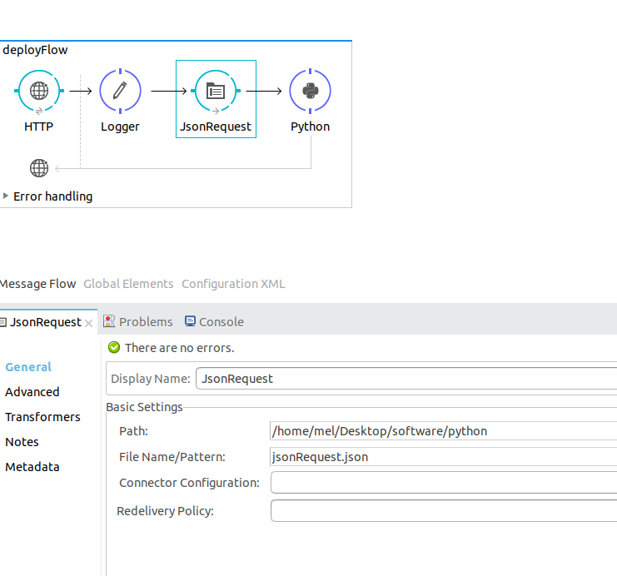

Python:

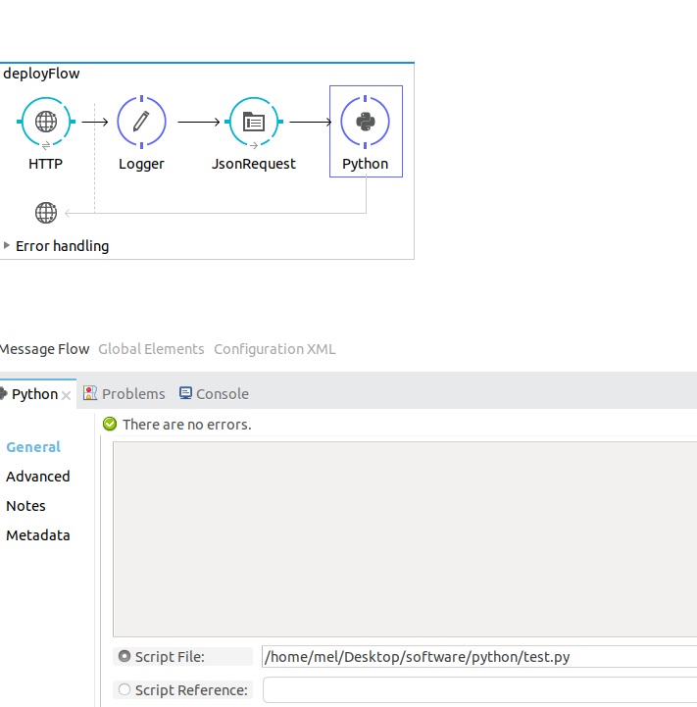

Through postman send Json file
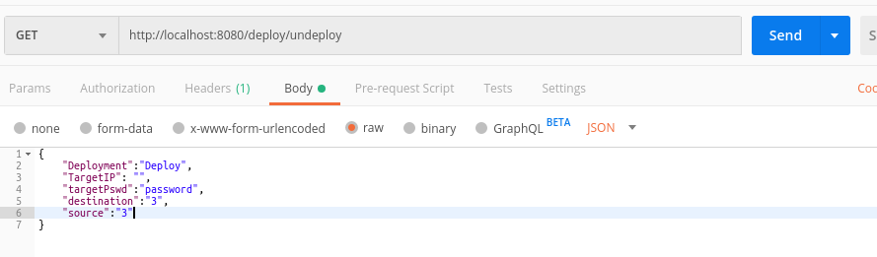

Http listens to the port if a request comes, the request goes through the logger. Logger keeps the request, file saves the json file to the given path. Then the python code gets the json file from the path and parses it. Deploys or undeploys then sends the response to the destination.

